Eric Pereira & Dmitri Piquero

Lab 12

Architecture & Assembly

November 26, 2018

FPU

Part 1.

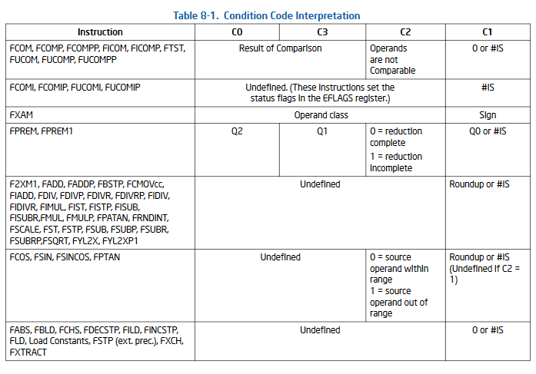

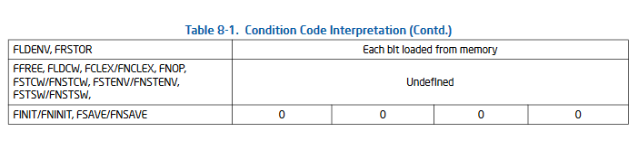

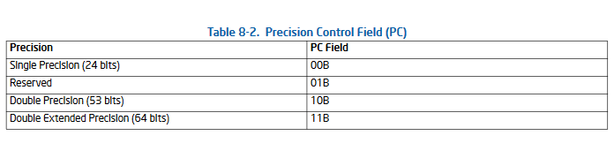

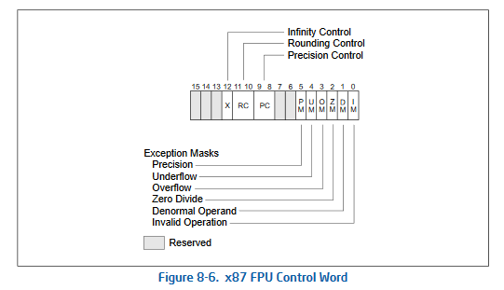

Part 2.

INCLUDE Irvine32.inc

.data

success BYTE "a happy message",0

_one REAL4 1.0

_two REAL4 2.0

.code

main PROC

FINIT

FILD _one ; _one should be defined as dword 1

FILD _two ; .... also load dword _two

FCOM ; compares _two, _one...... cf FCOMI

FNSTSW AX ; no wait for exceptions

SAHF

JNBE label_success

JMP label_failure

label_success:

MOV EDX, OFFSET success

CALL WriteString

; print a happy message

label_failure:

; exit

exit

main ENDP

END main

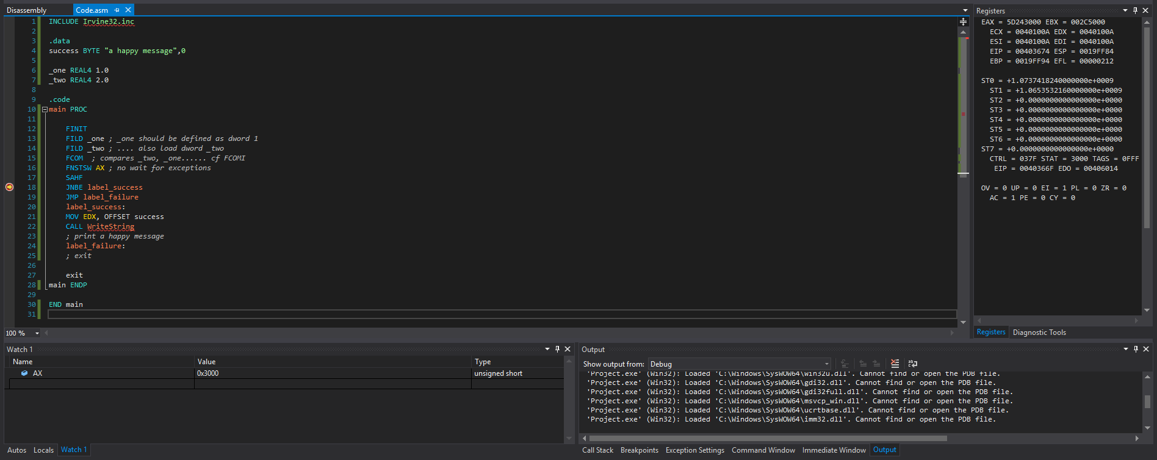

Part 3:

Ltext0:

.globl square_root_proc

.type square_root_proc, @function

.comm ctrlWord, 4

.text

square_root_proc:

FINIT

pushl %eax

FILD (%esp)

FSTCW ctrlWord

orw $0b110000000000, ctrlWord

FLDCW ctrlWord

FSQRT

FISTP (%esp) /* could have used FISTTP */

popl %eax

fstcw ctrlWord

andw $0b001111111111, ctrlWord

fldcw ctrlWord

ret